Mathematics Case study Analysis: Are women more embarrased by their Flatus more than Men
Name
Institutional Affiliation
Course
Date

1. plot two separate male and female histograms of the variable "perday" what do you notice when you compare the two graphs?

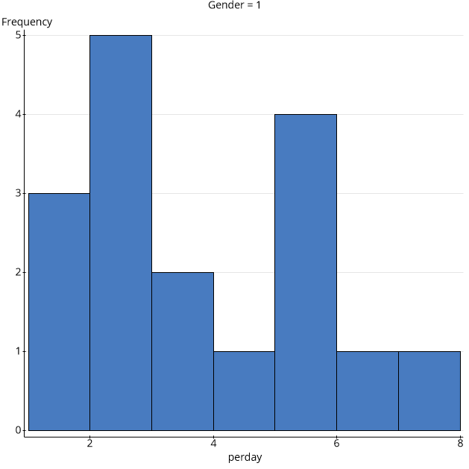
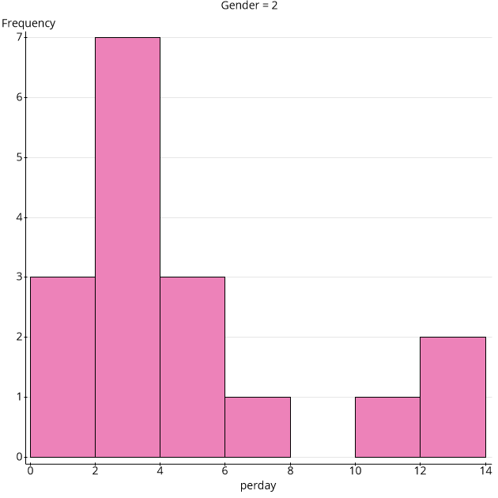
After comparing the two graphs, I notice that gender 1 female depicts high frequency levels of flatulency than their male counterparts.
2. Is there a relationship between number of male siblings and embarrassment in front of romantic interests? Create a scatter plot to identify this possible relationship and interpret your data.
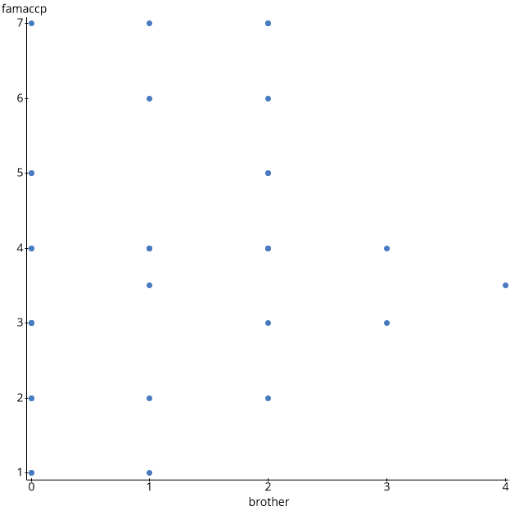
The possible relationship in this case is that those individuals with more male siblings find it less unacceptable. The scatter plot depicts that individuals with 4 brothers were found to be less likely than those individuals from families with 0 or 1 male sibling.
3. Create a scatterplot of variable "perday" as a function of how acceptable flatulence is in the family. Add a line of bestfit to the scatter plot. What is the relationship that you see between the two variables?
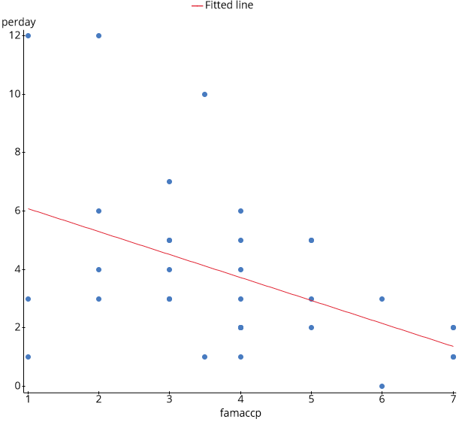
The two variables have a positive relationship as the number of flatulence cases perday increase as you move from left to right.
4.Create a stem-and-leaf plot of the variable "howlong.' Round your numbers accordingly so that you can plot one digit in your leaf column and use a key with your plot. What can you say about the shape of the distribution (or the location of the data points)?. Use percentages in your description if needed. What information can ytou draw from the data from this variable?

Variable: "howlong"
Decimal point is at the colon.
Leaf unit = 0.1
0 : 111133
0 : 555555555555888
1 : 0000000000
1 :
2 : 00

High: 3
The lengths of the rows are similar to the heights of bars in a histogram: longer rows of data correspond to smaller frequencies
- Construct a frequency distribution table using talkprof category. Recall that the embarrasing situation is rated on a scale of 1 to 7 where 1=extremely embarrassed and 7=not really embarrassed. Round your decimals to the thousandths place value.

Frequency table results for howlong:
Count = 34
score | Frequency | Relative Frequency | Cumulative Frequency | Cumulative Relative Frequency
0.1 | 4 | 0.11764706 | 4 | 0.11764706
0.25 | 2 | 0.058823529 | 6 | 0.17647059
0.5 | 12 | 0.35294118 | 18 | 0.52941176
0.75 | 3 | 0.088235294 | 21 | 0.61764706
1 | 10 | 0.29411765 | 31 | 0.91176471
2 | 2 | 0.058823529 | 33 | 0.97058824
3 | 1 | 0.029411765 | 34 | 1

- Answer the final question of the case study, "Are women or men more embarrassed by their flatus?" Choose (from Q#1-5) what you feel is the best type of statistical table(s) or graphs to help you estimate an answer this question and explain why you choose it. provide the graphs or tables in your answer.
From the above statistical analysis methods, the hypothesis that women are more embarrassed by their flatus is supported; therefore, it is true. This is clearly supported by the histograms as it groups each gender separately which is also the reason as to why I choosae the method.
For males (Gender-1)

Gender-2 Female

